Resume
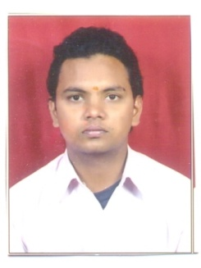
Gajendra Sahu
A-26, Prince Hill Colony,
Badi Nagfhani,Gopal Kund Near,
Ajmer -305001 (Raj.)
E-Mail Id: - bablusahu56@gmail.com
Mob. No. 9929926649

Career Objective:

To be a part of challenging work group and to contribute to the growth of the firm with new initiative, development and honesty that the industry demands from an individual.

Qualification:-

- Secondary from R.B.S.E Board, Ajmer in 2007.
- Sr. Secondary (Commerce) from R.B.S.E. Board, Ajmer in 2009.
- Bachelor of Computer Applications (B.C.A) from M.D.S. University, Ajmer in 2012.

Personal Strength

- Confidence
- Self Motivate
- Hard working
- Positive Attitude
- Straight Forward Thinking

Other Activities:-

- English Typing
- C Language

Experience:-

- Presently working as computer operator cum clerk under the contractor-ship of the undersigned at M/s HMT Machine Tools Limited, Beawar Road, Ajmer. Look after assisting several Multi-dimensional activities carried out in Purchase Deptt. on Computer like Preparation of Oracle , M.S. Office, Finance Concurrence(F.C), Purchase Orders(PO), Tender Enquiry, GeM Portal create Bidding, Place GeM contract, CRAC etc. Since 2012.

- Two Month experience at Board Of Secondary Education Rajasthan, Ajmer as a Computer Operator.

Personal Profile:-

- Father’s Name : Shri Ghanshyam Sahu
- Mather ‘s Name : Smt. Manju Sahu
- Date of Birth : 06th Nov.,1989
- Marital Status : Married.
- Nationality : Indian
- Hobbies : Listening Music
- Language : Hind & English

Place:-Ajmer

Date :- (Gajendra Sahu)

